WOULDHAM PARISH COUNCIL
STATEMENT ON INTERNAL CONTROL
FOR THE YEAR ENDING 31st MARCH 2022

1. SCOPE OF RESPONSIBILITY

Wouldham Parish Council (the Council) is responsible for ensuring that its business is conducted in accordance with the law and proper standards, and that public money is safeguarded and properly accounted for, and used economically, efficiently and effectively.
In discharging this overall responsibility, the Council is also responsible for ensuring that there is a sound system of internal control, including the preparation of the accounting statements as required by Section 1 of the Annual Governance & Accountability Return (AGAR) – Annual Governance Statement and its 9 “assertions”.

2. THE PURPOSE OF THE SYSTEM OF INTERNAL CONTROL
The system of internal control is designed to manage risk to a reasonable level rather than to eliminate all risk of failure to achieve policies, aims and objectives; it can therefore only provide reasonable and not absolute assurance of effectiveness. The system of internal control is based on an ongoing process designed to identify and prioritise the risks to the achievement of the Council’s policies, aims and objectives, to evaluate the likelihood of those risks being realised and the impact should they be realised, and to manage them efficiently, effectively and economically.

The Council has in place a set of Standing Orders and Financial Regulations, which set out the general rules applicable at council and committee meetings and in carrying out the council’s business. These two documents are reviewed on a regular basis and influence the system of internal controls in place.

The system of internal control has been in place at the Council for the year ended 31 March 2022 and up to the date of approval of the AGAR (annual governance statement and accounting statements) and, except for the details of significant internal control issues at section 5 of this Statement, accords with proper practice.

3. THE INTERNAL CONTROL ENVIRONMENT

The Council:
The Council has appointed a Chairman who is responsible for the smooth running of meetings and for ensuring that all Council decisions are lawful.

The Council reviews its obligations and objectives and approved budgets for the following year at its January meeting. The January meeting of the Council approved the level of precept for the following financial year.

The full Council meets eleven times each year and monitors progress against its aims and objectives at each meeting by receiving relevant reports from the Committees, Clerk and Councillors.

The Council carries out regular reviews of its internal controls, systems and procedures.

Clerk to the Council / Responsible Financial Officer:
The Council has appointed a Clerk to the Council who acts as the Council’s advisor and administrator. The Clerk is the Council’s Responsible Financial Officer and is responsible for administering the Council’s finances. The Clerk is responsible for the day-to-day compliance with laws and regulations that the Council is subject to and for managing risks. The Clerk also ensures that the Council’s procedures, control systems and policies are adhered to and reviewed as necessary.

Payments:
All payments are reported to the Council for approval. Two Members of the Council must authorise and sign a monthly payment request identifying all payments to be made during the month. The RFO will then pay the approved amounts via BAC’s/internet banking. This includes regular direct debit and standing orders. A different member of the Council must authorise payments against statement.
Expenditure on revenue items may be authorised up to the amounts included for that class of expenditure in the approved budget. This authority is to be determined by:
- the council for all items over £2500;
- a duly delegated committee of the council for items over £500; or

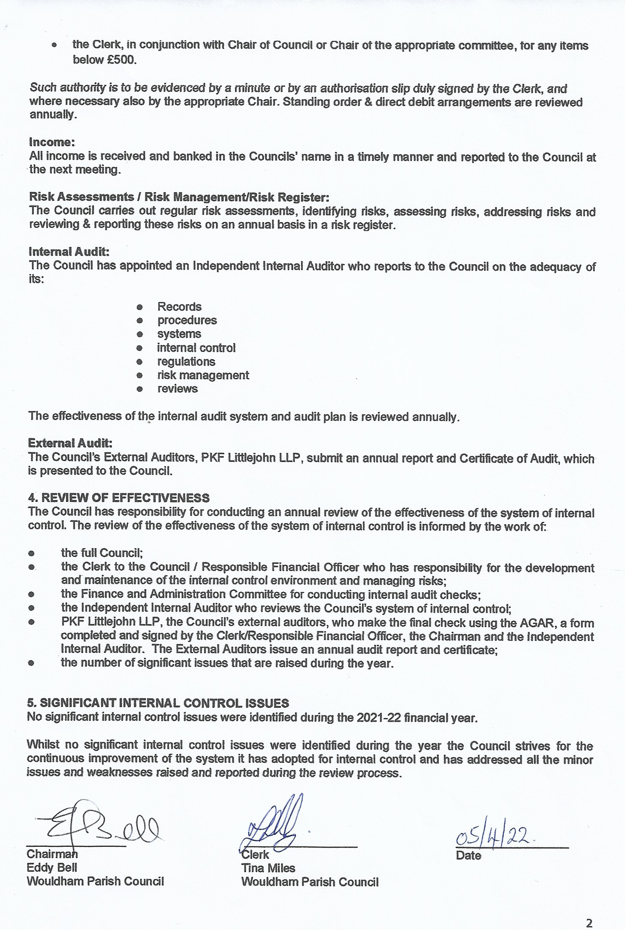
10/5/22

